**IFT 466 Advanced Computer Networks**

**Lab 19  
BGP – RIP + OSPF**

**Objective**Demonstrate how to configure two separate autonomous systems with different routing protocols (RIP + OSPF) and then using the BGP protocol to enable communications between these autonomous systems.

1. Setup up the following topology on Packet Tracer

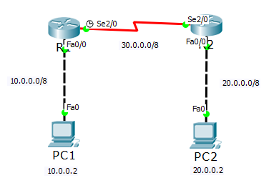

✓

1. Configure the PCS and routers with IP addresses on all interfaces using the addressing scheme on the topology above.

 ✓

1. Enable RIP on both routers along with the advertised networks. R1 is shown below

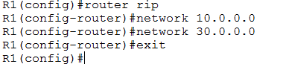

Repeat the same RIP process for R2



✓

1. Run the show ip route command on R1 see to the route table

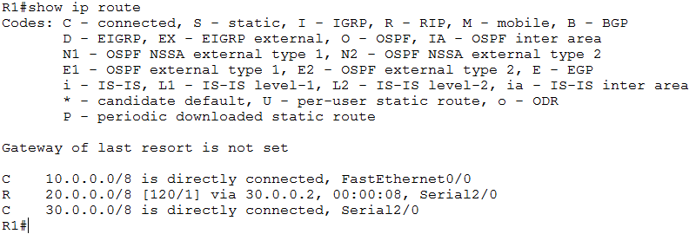  
  
 ✓

1. Now you should be able to Ping PC2 from PC1 (if not, then troubleshoot)



✓

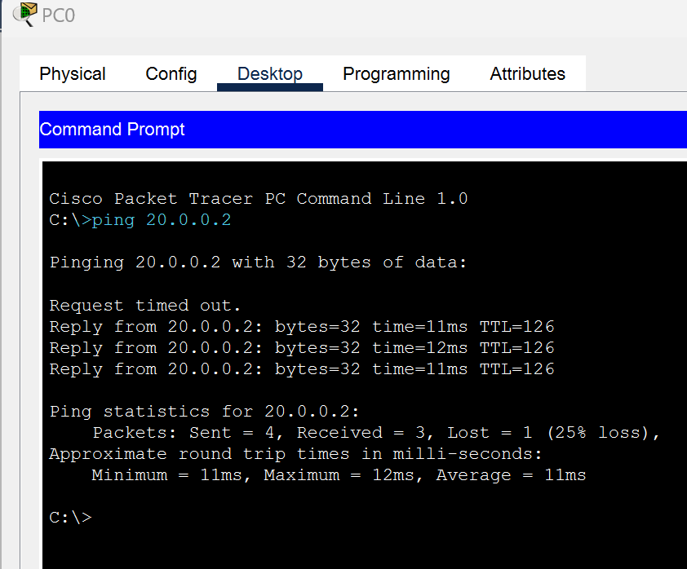

1. Now update the topology to the following

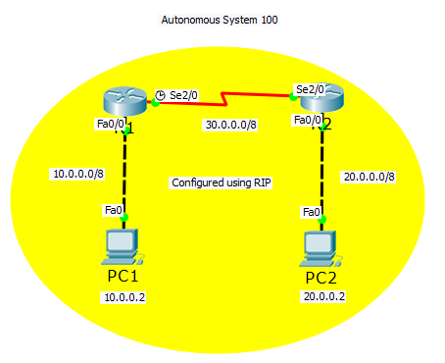

 ✓

1. Now setup another topology beside the existing RIP topology

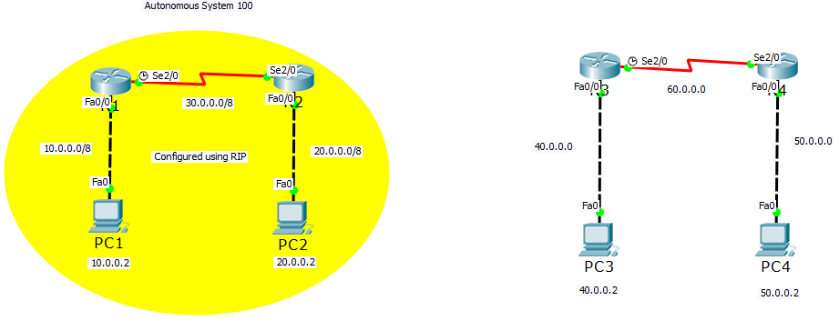

 ✓

1. Configure the PCS and routers with IP addresses on all interfaces.



✓

1. Now we will configure OSPF on both routers. R3 is show below.

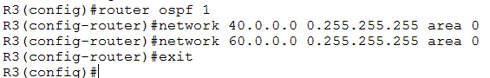

Repeat the same OSPF process for R4



✓

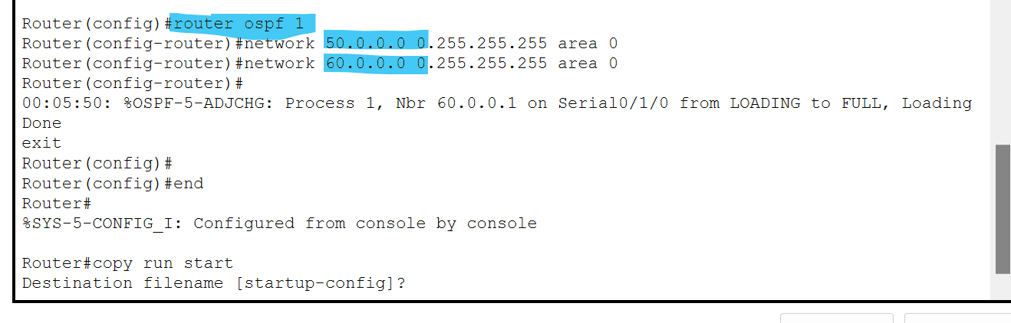

1. Run the show ip route command on R1 see to the route table

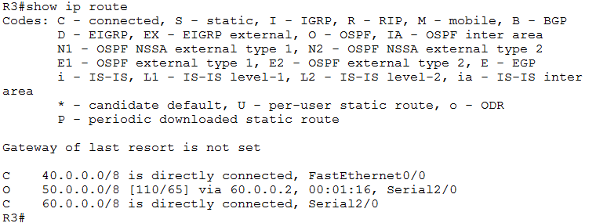

✓

1. Now you should be able to Ping PC2 from PC1 (if not, then troubleshoot)



✓

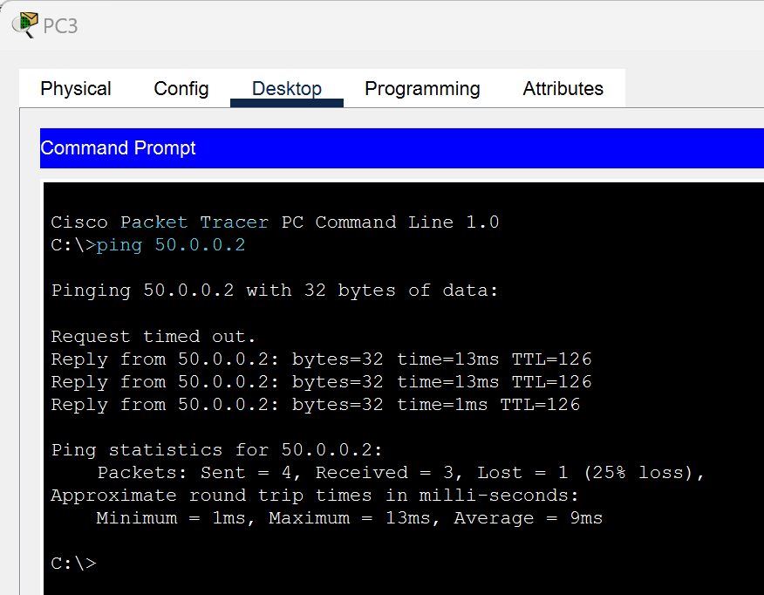

1. Now we have 2 autonomous systems configured using RIP and OSPF.   
     
   These two systems are separated (like two separate organizations using interior routing protocols i.e. RIP & OSPF) and if want information passed between these two systems, then we need to connect them using an exterior routing protocol.   
     
   For an exterior connection of autonomous systems we need we will use BGP.

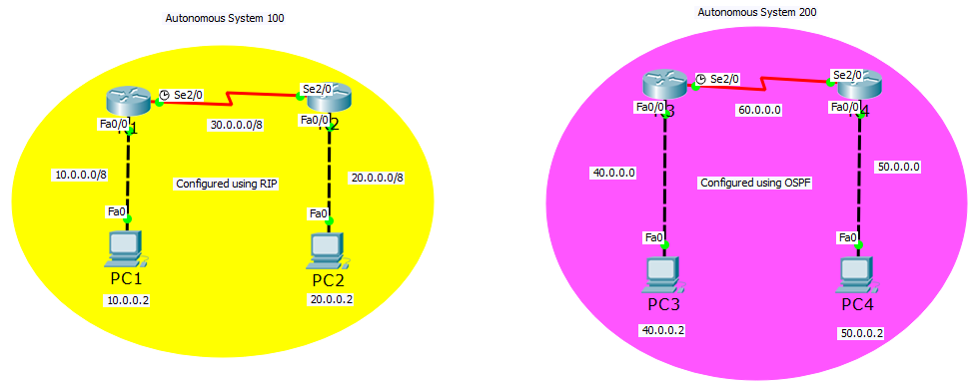

✓

1. No we will setup BGP. We will configure R2 and R3 with BGP and list/mention the neighbors that will communicate with each other e.g. PC2 and PC3.  
     
   Then only the two routers and two PCs can exchange information.



✓

1. Configure the interfaces on both R2 & R3 with the new IP address (70.0.0.0).

We can ping from R2 – R3.

We can not ping from PC2 to R3 as we have not configured the route.  
  
At the moment, from AS 100 to AS 200, transmission can only be done from R2 to R3.



✓

1. If we want PC2 to be able to communicate with AS 200 and PC3 to communicate with AS 100, we will need to configure it.

We will now configure R2 and only list to two networks as we only need PC2 to access the information so we do not need 30.0.0.0 network.

Then list the neighbors IP address of R3 and PC3

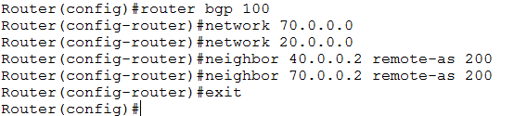

 ✓

1. We will now configure R3

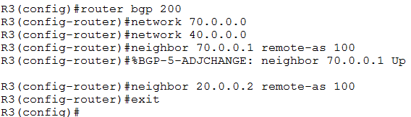

✓

1. Now run the show ip route command on R3

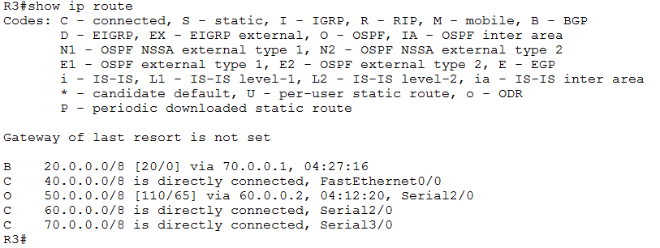

 ✓

1. Now ping from PC 2 to PC 3

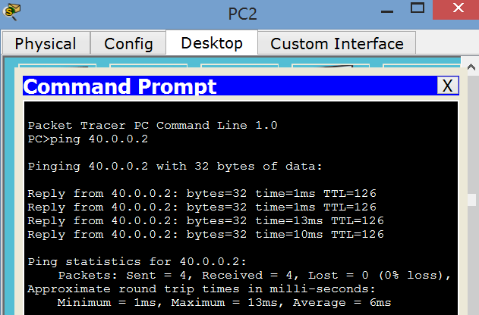

 ✓

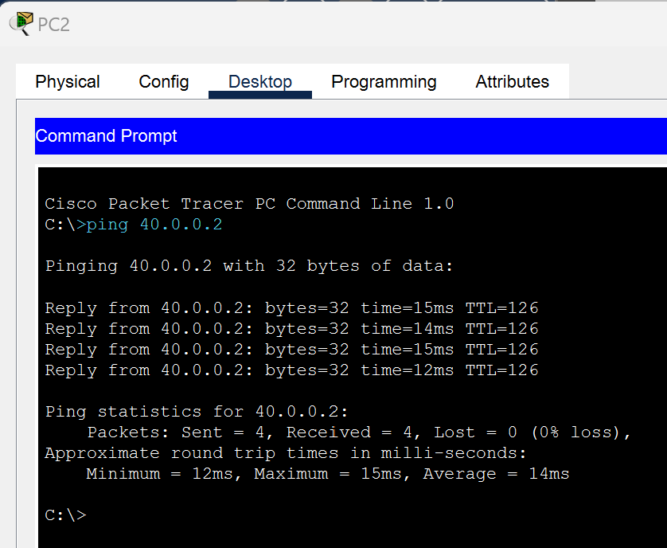

1. Can you ping from PC 1 to PC 3? **NO**

  
 All going well, you should not be able to…  
  
  
 ✓

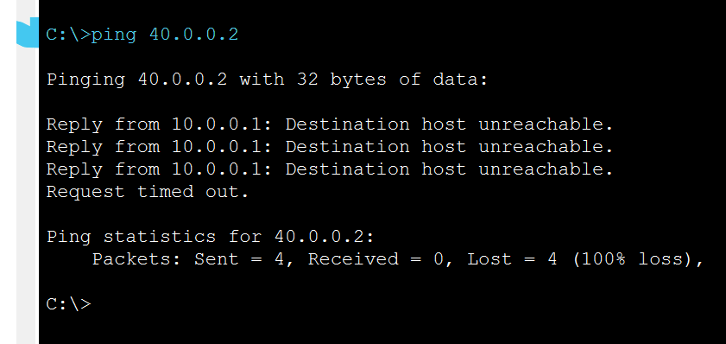

1. Now update the topology so you can ping from PC 1 to PC 3.

Attach a screenshot of your successful ping here.

